증폭 0 – Batch size 128 / 128 , Learning rate 0.01

#0 Loss: 1.9348 Acc: 46.5650% Time: 48.1921s

[Test Phase] Loss: 0.8064 Acc: 71.3333% Top3 Acc: 94.3333% Time: 50.7808s

#1 Loss: 0.5151 Acc: 84.2092% Time: 97.8089s

[Test Phase] Loss: 0.5704 Acc: 78.0000% Top3 Acc: 96.3333% Time: 100.3690s

#2 Loss: 0.1509 Acc: 96.2958% Time: 146.1272s

[Test Phase] Loss: 0.5149 Acc: 83.6667% Top3 Acc: 96.6667% Time: 149.0140s

#3 Loss: 0.0401 Acc: 99.4617% Time: 195.2381s

[Test Phase] Loss: 0.3457 Acc: 88.6667% Top3 Acc: 98.3333% Time: 198.3985s

#4 Loss: 0.0129 Acc: 99.8975% Time: 244.9212s

[Test Phase] Loss: 0.3437 Acc: 90.3333% Top3 Acc: 98.0000% Time: 247.5253s

#5 Loss: 0.0071 Acc: 99.9487% Time: 294.4524s

[Test Phase] Loss: 0.3464 Acc: 89.3333% Top3 Acc: 98.3333% Time: 296.8905s

#6 Loss: 0.0047 Acc: 99.9359% Time: 344.4065s

[Test Phase] Loss: 0.3515 Acc: 89.3333% Top3 Acc: 98.0000% Time: 347.0542s

#7 Loss: 0.0039 Acc: 99.9615% Time: 395.8014s

[Test Phase] Loss: 0.3566 Acc: 89.0000% Top3 Acc: 98.0000% Time: 398.8175s

#8 Loss: 0.0032 Acc: 99.9615% Time: 445.6115s

[Test Phase] Loss: 0.3533 Acc: 89.0000% Top3 Acc: 97.3333% Time: 448.5247s

#9 Loss: 0.0029 Acc: 99.9615% Time: 498.2993s

[Test Phase] Loss: 0.3531 Acc: 89.3333% Top3 Acc: 98.0000% Time: 501.0710s

#10 Loss: 0.0025 Acc: 99.9487% Time: 549.3842s

[Test Phase] Loss: 0.3575 Acc: 89.3333% Top3 Acc: 98.0000% Time: 551.9298s

#11 Loss: 0.0025 Acc: 99.9487% Time: 601.5560s

[Test Phase] Loss: 0.3637 Acc: 88.6667% Top3 Acc: 97.6667% Time: 604.0630s

#12 Loss: 0.0026 Acc: 99.9359% Time: 652.0192s

[Test Phase] Loss: 0.3643 Acc: 89.0000% Top3 Acc: 97.3333% Time: 654.6943s

#13 Loss: 0.0022 Acc: 99.9359% Time: 701.7784s

[Test Phase] Loss: 0.3657 Acc: 89.3333% Top3 Acc: 97.6667% Time: 704.6392s

#14 Loss: 0.0019 Acc: 99.9487% Time: 753.9198s

[Test Phase] Loss: 0.3676 Acc: 89.6667% Top3 Acc: 97.3333% Time: 756.7945s

#15 Loss: 0.0021 Acc: 99.9359% Time: 802.9048s

[Test Phase] Loss: 0.3775 Acc: 88.6667% Top3 Acc: 97.6667% Time: 805.4901s

#16 Loss: 0.0020 Acc: 99.9615% Time: 852.8609s

[Test Phase] Loss: 0.3680 Acc: 89.6667% Top3 Acc: 98.0000% Time: 855.6675s

#17 Loss: 0.0017 Acc: 99.9359% Time: 901.3462s

[Test Phase] Loss: 0.3777 Acc: 89.0000% Top3 Acc: 97.6667% Time: 904.0862s

#18 Loss: 0.0017 Acc: 99.9487% Time: 951.9094s

[Test Phase] Loss: 0.3758 Acc: 89.3333% Top3 Acc: 97.6667% Time: 954.6703s

#19 Loss: 0.0017 Acc: 99.9615% Time: 1002.4640s

[Test Phase] Loss: 0.3796 Acc: 89.6667% Top3 Acc: 97.3333% Time: 1005.0119s

#20 Loss: 0.0017 Acc: 99.9487% Time: 1052.0232s

[Test Phase] Loss: 0.3680 Acc: 89.6667% Top3 Acc: 98.0000% Time: 1054.5898s

#21 Loss: 0.0016 Acc: 99.9231% Time: 1102.4942s

[Test Phase] Loss: 0.3741 Acc: 90.0000% Top3 Acc: 97.0000% Time: 1105.0067s

#22 Loss: 0.0013 Acc: 99.9615% Time: 1150.8527s

[Test Phase] Loss: 0.3734 Acc: 89.3333% Top3 Acc: 97.0000% Time: 1153.3306s

#23 Loss: 0.0015 Acc: 99.9487% Time: 1200.8877s

[Test Phase] Loss: 0.3809 Acc: 89.0000% Top3 Acc: 97.3333% Time: 1203.4229s

#24 Loss: 0.0015 Acc: 99.9487% Time: 1250.4870s

[Test Phase] Loss: 0.3791 Acc: 89.3333% Top3 Acc: 97.6667% Time: 1253.0492s

#25 Loss: 0.0015 Acc: 99.9615% Time: 1301.1237s

[Test Phase] Loss: 0.3805 Acc: 89.3333% Top3 Acc: 97.3333% Time: 1304.0650s

#26 Loss: 0.0015 Acc: 99.9487% Time: 1349.8586s

[Test Phase] Loss: 0.3752 Acc: 89.6667% Top3 Acc: 97.3333% Time: 1352.3679s

#27 Loss: 0.0014 Acc: 99.9487% Time: 1398.7423s

[Test Phase] Loss: 0.3840 Acc: 89.6667% Top3 Acc: 97.6667% Time: 1401.1055s

#28 Loss: 0.0013 Acc: 99.9487% Time: 1447.8269s

[Test Phase] Loss: 0.3800 Acc: 89.3333% Top3 Acc: 97.0000% Time: 1450.3337s

#29 Loss: 0.0012 Acc: 99.9487% Time: 1497.4436s

[Test Phase] Loss: 0.3794 Acc: 89.3333% Top3 Acc: 97.6667% Time: 1499.8744s

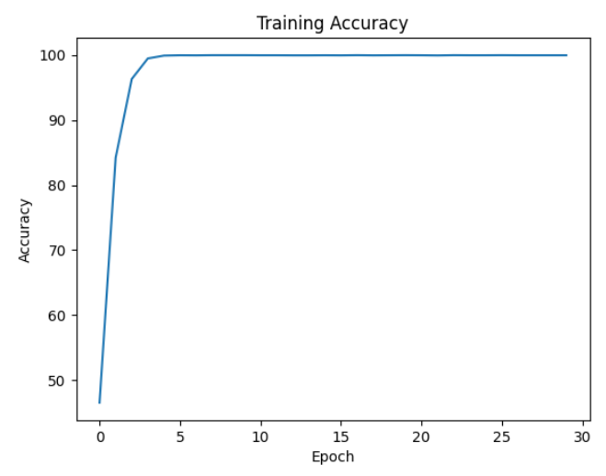 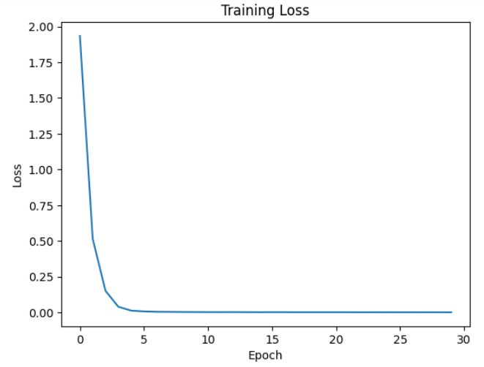 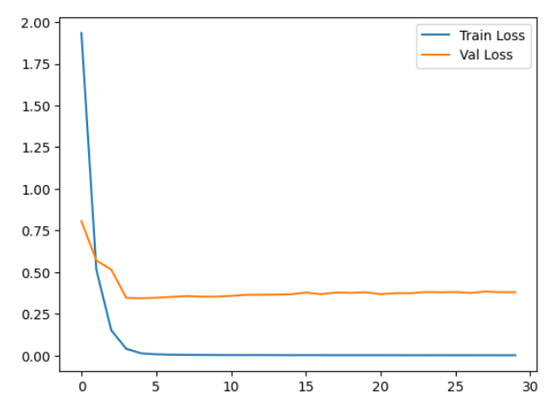

증폭 0 – Batch size 32 / 32 , Learning rate 0.001

#0 Loss: 2.3807 Acc: 37.2725% Time: 48.2553s

[Test Phase] Loss: 1.2387 Acc: 67.6667% Top3 Acc: 87.0000% Time: 50.1854s

#1 Loss: 1.0238 Acc: 71.7765% Time: 100.1025s

[Test Phase] Loss: 0.6721 Acc: 79.6667% Top3 Acc: 94.3333% Time: 101.8368s

#2 Loss: 0.5305 Acc: 86.3112% Time: 153.8914s

[Test Phase] Loss: 0.5064 Acc: 85.3333% Top3 Acc: 97.3333% Time: 155.9605s

#3 Loss: 0.2741 Acc: 93.9246% Time: 203.8701s

[Test Phase] Loss: 0.4147 Acc: 88.6667% Top3 Acc: 97.0000% Time: 205.6946s

#4 Loss: 0.1363 Acc: 98.0774% Time: 254.6940s

[Test Phase] Loss: 0.3927 Acc: 88.0000% Top3 Acc: 97.6667% Time: 256.4065s

#5 Loss: 0.0702 Acc: 99.5258% Time: 309.4440s

[Test Phase] Loss: 0.3700 Acc: 89.0000% Top3 Acc: 98.0000% Time: 311.1695s

#6 Loss: 0.0410 Acc: 99.7821% Time: 361.8747s

[Test Phase] Loss: 0.3689 Acc: 88.0000% Top3 Acc: 98.0000% Time: 363.6539s

#7 Loss: 0.0276 Acc: 99.8846% Time: 415.2985s

[Test Phase] Loss: 0.3521 Acc: 90.3333% Top3 Acc: 98.6667% Time: 417.1911s

#8 Loss: 0.0203 Acc: 99.9103% Time: 468.3769s

[Test Phase] Loss: 0.3647 Acc: 89.3333% Top3 Acc: 98.6667% Time: 470.1565s

#9 Loss: 0.0166 Acc: 99.9231% Time: 521.1537s

[Test Phase] Loss: 0.3753 Acc: 90.6667% Top3 Acc: 98.0000% Time: 522.9303s

#10 Loss: 0.0130 Acc: 99.9487% Time: 572.2241s

[Test Phase] Loss: 0.3608 Acc: 90.3333% Top3 Acc: 98.3333% Time: 574.0007s

#11 Loss: 0.0121 Acc: 99.8975% Time: 626.6202s

[Test Phase] Loss: 0.3605 Acc: 90.3333% Top3 Acc: 98.0000% Time: 628.6362s

#12 Loss: 0.0103 Acc: 99.9487% Time: 678.0316s

[Test Phase] Loss: 0.3705 Acc: 89.6667% Top3 Acc: 99.0000% Time: 679.8267s

#13 Loss: 0.0090 Acc: 99.9359% Time: 728.4132s

[Test Phase] Loss: 0.3662 Acc: 90.6667% Top3 Acc: 98.3333% Time: 730.4766s

#14 Loss: 0.0080 Acc: 99.9359% Time: 780.9257s

[Test Phase] Loss: 0.3659 Acc: 90.3333% Top3 Acc: 97.6667% Time: 783.0387s

#15 Loss: 0.0077 Acc: 99.9359% Time: 833.9913s

[Test Phase] Loss: 0.3686 Acc: 90.6667% Top3 Acc: 98.6667% Time: 835.9967s

#16 Loss: 0.0062 Acc: 99.9487% Time: 885.4975s

[Test Phase] Loss: 0.3762 Acc: 90.6667% Top3 Acc: 98.3333% Time: 887.1953s

#17 Loss: 0.0061 Acc: 99.9615% Time: 937.9453s

[Test Phase] Loss: 0.4000 Acc: 89.6667% Top3 Acc: 98.3333% Time: 939.7169s

#18 Loss: 0.0053 Acc: 99.9487% Time: 990.8613s

[Test Phase] Loss: 0.3907 Acc: 90.6667% Top3 Acc: 97.6667% Time: 992.7557s

#19 Loss: 0.0055 Acc: 99.9359% Time: 1044.8123s

[Test Phase] Loss: 0.4082 Acc: 89.0000% Top3 Acc: 98.0000% Time: 1046.7644s

#20 Loss: 0.0048 Acc: 99.9615% Time: 1094.9708s

[Test Phase] Loss: 0.4016 Acc: 89.6667% Top3 Acc: 97.6667% Time: 1096.8473s

#21 Loss: 0.0045 Acc: 99.9231% Time: 1146.8163s

[Test Phase] Loss: 0.3967 Acc: 90.3333% Top3 Acc: 99.0000% Time: 1149.0358s

#22 Loss: 0.0053 Acc: 99.9359% Time: 1199.9986s

[Test Phase] Loss: 0.4135 Acc: 89.0000% Top3 Acc: 98.3333% Time: 1201.6558s

#23 Loss: 0.0044 Acc: 99.9231% Time: 1251.5538s

[Test Phase] Loss: 0.4004 Acc: 89.6667% Top3 Acc: 98.3333% Time: 1253.5934s

#24 Loss: 0.0048 Acc: 99.9359% Time: 1303.7495s

[Test Phase] Loss: 0.4149 Acc: 90.0000% Top3 Acc: 98.6667% Time: 1305.3708s

#25 Loss: 0.0042 Acc: 99.9615% Time: 1354.0809s

[Test Phase] Loss: 0.4086 Acc: 90.0000% Top3 Acc: 98.3333% Time: 1356.0524s

#26 Loss: 0.0039 Acc: 99.9487% Time: 1403.2310s

[Test Phase] Loss: 0.4281 Acc: 90.0000% Top3 Acc: 98.0000% Time: 1405.1443s

#27 Loss: 0.0036 Acc: 99.9615% Time: 1456.3067s

[Test Phase] Loss: 0.4145 Acc: 89.3333% Top3 Acc: 98.3333% Time: 1458.1758s

#28 Loss: 0.0034 Acc: 99.9615% Time: 1507.1979s

[Test Phase] Loss: 0.4123 Acc: 90.3333% Top3 Acc: 98.3333% Time: 1509.0392s

#29 Loss: 0.0035 Acc: 99.9872% Time: 1556.0445s

[Test Phase] Loss: 0.4238 Acc: 90.0000% Top3 Acc: 98.3333% Time: 1558.0615s

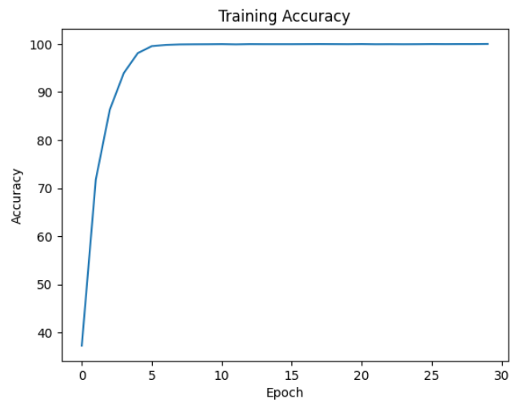 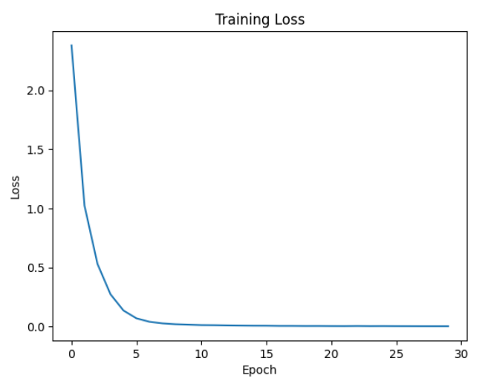 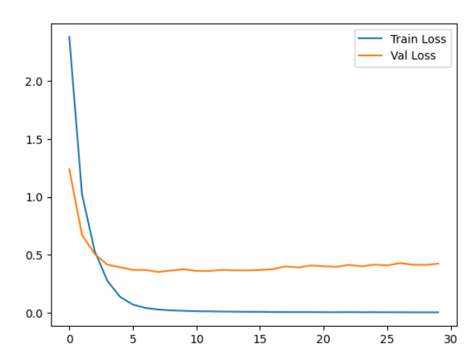

증폭 2 - Batch size 128 / 128 , Learning rate 0.01

#0 Loss: 1.8583 Acc: 45.8253% Time: 69.4613s

[Test Phase] Loss: 0.7131 Acc: 76.6667% Top3 Acc: 93.0000% Time: 73.8124s

#1 Loss: 0.8612 Acc: 73.9178% Time: 132.6158s

[Test Phase] Loss: 0.4983 Acc: 81.6667% Top3 Acc: 97.6667% Time: 135.3484s

#2 Loss: 0.5373 Acc: 84.1362% Time: 193.1130s

[Test Phase] Loss: 0.5679 Acc: 82.3333% Top3 Acc: 97.0000% Time: 196.1487s

#3 Loss: 0.3469 Acc: 89.9743% Time: 255.1653s

[Test Phase] Loss: 0.4051 Acc: 89.0000% Top3 Acc: 98.3333% Time: 258.0446s

#4 Loss: 0.2384 Acc: 93.0122% Time: 314.2176s

[Test Phase] Loss: 0.4242 Acc: 87.3333% Top3 Acc: 98.0000% Time: 317.2455s

#5 Loss: 0.1650 Acc: 95.0353% Time: 373.3681s

[Test Phase] Loss: 0.4689 Acc: 85.3333% Top3 Acc: 98.0000% Time: 376.4164s

#6 Loss: 0.1135 Acc: 96.8401% Time: 434.1667s

[Test Phase] Loss: 0.4956 Acc: 87.0000% Top3 Acc: 97.3333% Time: 437.2587s

#7 Loss: 0.0774 Acc: 97.7200% Time: 495.0282s

[Test Phase] Loss: 0.3787 Acc: 89.0000% Top3 Acc: 98.0000% Time: 497.8195s

#8 Loss: 0.0628 Acc: 98.3301% Time: 558.9628s

[Test Phase] Loss: 0.4069 Acc: 90.0000% Top3 Acc: 98.6667% Time: 561.6816s

#9 Loss: 0.0354 Acc: 99.0687% Time: 621.7425s

[Test Phase] Loss: 0.4219 Acc: 90.6667% Top3 Acc: 99.0000% Time: 624.8083s

#10 Loss: 0.0273 Acc: 99.3128% Time: 685.3686s

[Test Phase] Loss: 0.3875 Acc: 88.0000% Top3 Acc: 99.6667% Time: 688.2981s

#11 Loss: 0.0188 Acc: 99.5890% Time: 751.5244s

[Test Phase] Loss: 0.3844 Acc: 89.6667% Top3 Acc: 99.0000% Time: 754.5828s

#12 Loss: 0.0090 Acc: 99.8138% Time: 816.8801s

[Test Phase] Loss: 0.3739 Acc: 90.6667% Top3 Acc: 99.3333% Time: 820.0677s

#13 Loss: 0.0061 Acc: 99.8780% Time: 881.4233s

[Test Phase] Loss: 0.3658 Acc: 90.3333% Top3 Acc: 99.0000% Time: 884.8315s

#14 Loss: 0.0028 Acc: 99.9615% Time: 944.9420s

[Test Phase] Loss: 0.3485 Acc: 91.0000% Top3 Acc: 99.0000% Time: 948.6097s

#15 Loss: 0.0022 Acc: 99.9422% Time: 1009.2236s

[Test Phase] Loss: 0.3514 Acc: 91.3333% Top3 Acc: 99.3333% Time: 1012.6644s

#16 Loss: 0.0017 Acc: 99.9615% Time: 1072.2877s

[Test Phase] Loss: 0.3466 Acc: 91.3333% Top3 Acc: 99.3333% Time: 1075.4897s

#17 Loss: 0.0021 Acc: 99.9294% Time: 1145.3171s

[Test Phase] Loss: 0.3422 Acc: 91.6667% Top3 Acc: 99.3333% Time: 1149.7181s

#18 Loss: 0.0015 Acc: 99.9550% Time: 1215.3185s

[Test Phase] Loss: 0.3443 Acc: 92.0000% Top3 Acc: 99.3333% Time: 1218.5498s

#19 Loss: 0.0013 Acc: 99.9679% Time: 1276.1421s

[Test Phase] Loss: 0.3596 Acc: 92.0000% Top3 Acc: 99.3333% Time: 1279.0793s

#20 Loss: 0.0011 Acc: 99.9743% Time: 1336.8986s

[Test Phase] Loss: 0.3553 Acc: 92.0000% Top3 Acc: 99.3333% Time: 1339.9622s

#21 Loss: 0.0010 Acc: 99.9679% Time: 1402.1087s

[Test Phase] Loss: 0.3455 Acc: 92.0000% Top3 Acc: 99.3333% Time: 1406.2030s

#22 Loss: 0.0011 Acc: 99.9679% Time: 1468.2661s

[Test Phase] Loss: 0.3596 Acc: 92.0000% Top3 Acc: 99.3333% Time: 1471.3348s

#23 Loss: 0.0011 Acc: 99.9615% Time: 1528.8818s

[Test Phase] Loss: 0.3538 Acc: 92.0000% Top3 Acc: 99.3333% Time: 1532.1254s

#24 Loss: 0.0010 Acc: 99.9486% Time: 1590.7581s

[Test Phase] Loss: 0.3538 Acc: 91.6667% Top3 Acc: 99.3333% Time: 1593.9936s

#25 Loss: 0.0010 Acc: 99.9615% Time: 1651.3502s

[Test Phase] Loss: 0.3584 Acc: 91.6667% Top3 Acc: 99.3333% Time: 1654.5665s

#26 Loss: 0.0008 Acc: 99.9743% Time: 1712.7590s

[Test Phase] Loss: 0.3607 Acc: 92.0000% Top3 Acc: 99.3333% Time: 1715.7337s

#27 Loss: 0.0007 Acc: 99.9807% Time: 1778.1470s

[Test Phase] Loss: 0.3645 Acc: 91.6667% Top3 Acc: 99.3333% Time: 1781.2776s

#28 Loss: 0.0008 Acc: 99.9679% Time: 1839.5448s

[Test Phase] Loss: 0.3586 Acc: 91.6667% Top3 Acc: 99.3333% Time: 1842.5203s

#29 Loss: 0.0011 Acc: 99.9486% Time: 1900.5388s

[Test Phase] Loss: 0.3564 Acc: 92.0000% Top3 Acc: 99.3333% Time: 1903.4808s

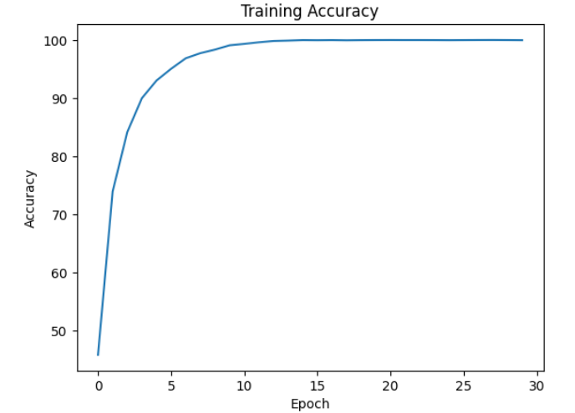 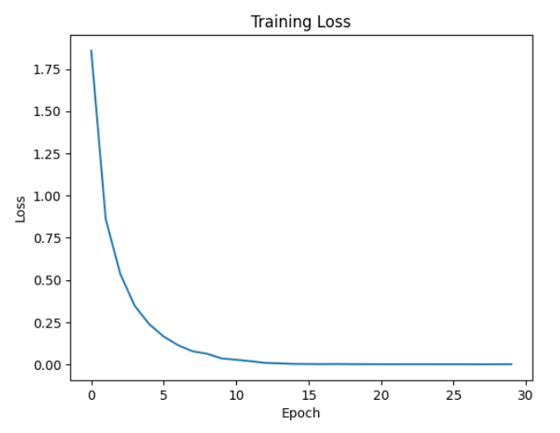 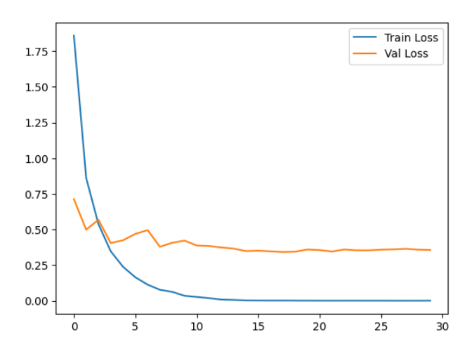

증폭 2 - Batch size 32 / 32 , Learning rate 0.001

#0 Loss: 2.2353 Acc: 38.1567% Time: 83.7859s

[Test Phase] Loss: 0.9363 Acc: 69.6667% Top3 Acc: 89.6667% Time: 85.9272s

#1 Loss: 1.1590 Acc: 66.2107% Time: 148.6769s

[Test Phase] Loss: 0.5203 Acc: 84.6667% Top3 Acc: 97.0000% Time: 150.8599s

#2 Loss: 0.7678 Acc: 78.0540% Time: 215.3413s

[Test Phase] Loss: 0.4159 Acc: 85.0000% Top3 Acc: 98.0000% Time: 217.6806s

#3 Loss: 0.5301 Acc: 84.9839% Time: 282.0961s

[Test Phase] Loss: 0.3638 Acc: 87.6667% Top3 Acc: 99.0000% Time: 284.2080s

#4 Loss: 0.3662 Acc: 90.2633% Time: 349.2815s

[Test Phase] Loss: 0.3945 Acc: 87.0000% Top3 Acc: 97.6667% Time: 351.4199s

#5 Loss: 0.2536 Acc: 93.5710% Time: 419.1583s

[Test Phase] Loss: 0.3314 Acc: 89.3333% Top3 Acc: 98.3333% Time: 421.3028s

#6 Loss: 0.1672 Acc: 95.8382% Time: 486.1946s

[Test Phase] Loss: 0.3678 Acc: 88.3333% Top3 Acc: 98.3333% Time: 488.6785s

#7 Loss: 0.1224 Acc: 97.1355% Time: 555.1352s

[Test Phase] Loss: 0.3777 Acc: 88.0000% Top3 Acc: 98.3333% Time: 557.3790s

#8 Loss: 0.0770 Acc: 98.2402% Time: 622.1165s

[Test Phase] Loss: 0.3163 Acc: 90.3333% Top3 Acc: 98.3333% Time: 624.2829s

#9 Loss: 0.0540 Acc: 99.0109% Time: 691.1226s

[Test Phase] Loss: 0.3676 Acc: 89.3333% Top3 Acc: 98.0000% Time: 693.9173s

#10 Loss: 0.0383 Acc: 99.3385% Time: 761.8613s

[Test Phase] Loss: 0.3310 Acc: 91.0000% Top3 Acc: 99.3333% Time: 764.0803s

#11 Loss: 0.0313 Acc: 99.4477% Time: 833.0851s

[Test Phase] Loss: 0.3417 Acc: 90.3333% Top3 Acc: 99.3333% Time: 835.7659s

#12 Loss: 0.0218 Acc: 99.6532% Time: 904.7380s

[Test Phase] Loss: 0.3213 Acc: 90.6667% Top3 Acc: 100.0000% Time: 907.0261s

#13 Loss: 0.0190 Acc: 99.7431% Time: 977.3633s

[Test Phase] Loss: 0.3723 Acc: 89.0000% Top3 Acc: 98.3333% Time: 979.7296s

#14 Loss: 0.0195 Acc: 99.6532% Time: 1047.6522s

[Test Phase] Loss: 0.3304 Acc: 89.0000% Top3 Acc: 99.0000% Time: 1049.8596s

#15 Loss: 0.0148 Acc: 99.7816% Time: 1124.9519s

[Test Phase] Loss: 0.3732 Acc: 89.3333% Top3 Acc: 98.3333% Time: 1128.1413s

#16 Loss: 0.0114 Acc: 99.8780% Time: 1205.4957s

[Test Phase] Loss: 0.3757 Acc: 90.0000% Top3 Acc: 98.6667% Time: 1207.4454s

#17 Loss: 0.0085 Acc: 99.9165% Time: 1271.1709s

[Test Phase] Loss: 0.3596 Acc: 90.3333% Top3 Acc: 98.3333% Time: 1273.2736s

#18 Loss: 0.0077 Acc: 99.9037% Time: 1337.5957s

[Test Phase] Loss: 0.3290 Acc: 89.3333% Top3 Acc: 99.3333% Time: 1340.0204s

#19 Loss: 0.0064 Acc: 99.9294% Time: 1409.5379s

[Test Phase] Loss: 0.3541 Acc: 90.3333% Top3 Acc: 99.0000% Time: 1411.9367s

#20 Loss: 0.0064 Acc: 99.9294% Time: 1478.7002s

[Test Phase] Loss: 0.3854 Acc: 91.3333% Top3 Acc: 98.6667% Time: 1481.0253s

#21 Loss: 0.0043 Acc: 99.9679% Time: 1546.6964s

[Test Phase] Loss: 0.3615 Acc: 90.6667% Top3 Acc: 98.6667% Time: 1549.0203s

#22 Loss: 0.0052 Acc: 99.9486% Time: 1613.9259s

[Test Phase] Loss: 0.3491 Acc: 90.0000% Top3 Acc: 99.0000% Time: 1616.5652s

#23 Loss: 0.0044 Acc: 99.9550% Time: 1683.3785s

[Test Phase] Loss: 0.3613 Acc: 90.3333% Top3 Acc: 98.6667% Time: 1685.6769s

#24 Loss: 0.0041 Acc: 99.9486% Time: 1752.2262s

[Test Phase] Loss: 0.3360 Acc: 91.0000% Top3 Acc: 99.0000% Time: 1754.2365s

#25 Loss: 0.0037 Acc: 99.9550% Time: 1823.1852s

[Test Phase] Loss: 0.3394 Acc: 89.6667% Top3 Acc: 99.3333% Time: 1825.4639s

#26 Loss: 0.0027 Acc: 99.9807% Time: 1892.8758s

[Test Phase] Loss: 0.3553 Acc: 91.3333% Top3 Acc: 98.6667% Time: 1894.9904s

#27 Loss: 0.0031 Acc: 99.9550% Time: 1961.2463s

[Test Phase] Loss: 0.3533 Acc: 90.6667% Top3 Acc: 99.0000% Time: 1963.4037s

#28 Loss: 0.0035 Acc: 99.9294% Time: 2028.8234s

[Test Phase] Loss: 0.3458 Acc: 90.3333% Top3 Acc: 98.6667% Time: 2031.0077s

#29 Loss: 0.0031 Acc: 99.9743% Time: 2095.6301s

[Test Phase] Loss: 0.3588 Acc: 89.6667% Top3 Acc: 99.0000% Time: 2097.6570s

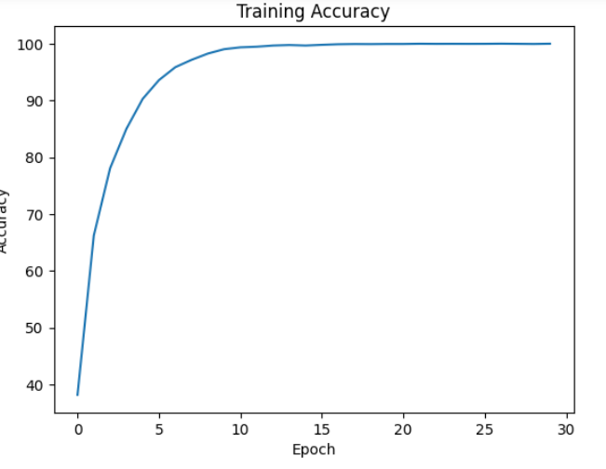 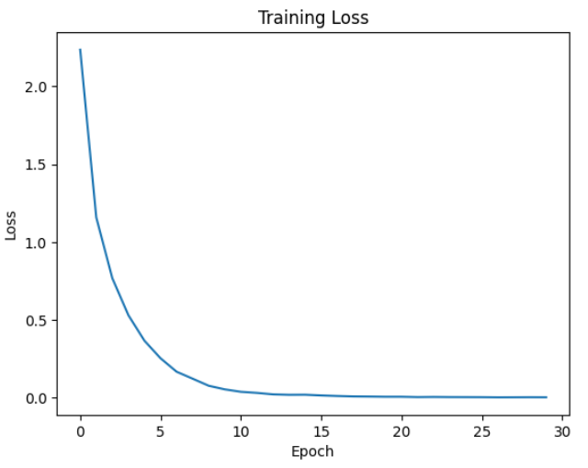 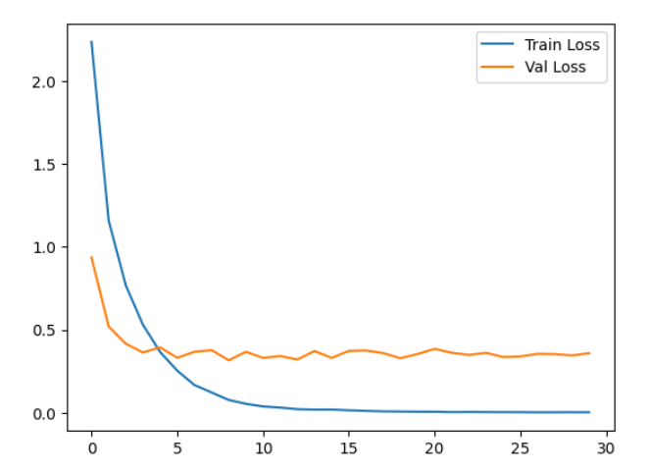

증폭 3 - Batch size 128 / 128 , Learning rate 0.01

#0 Loss: 1.7207 Acc: 49.3599% Time: 86.3288s

[Test Phase] Loss: 0.6825 Acc: 78.0000% Top3 Acc: 95.0000% Time: 88.9174s

#1 Loss: 0.8702 Acc: 73.7401% Time: 166.7106s

[Test Phase] Loss: 0.4926 Acc: 84.0000% Top3 Acc: 96.6667% Time: 169.3506s

#2 Loss: 0.5659 Acc: 82.8773% Time: 246.7114s

[Test Phase] Loss: 0.4989 Acc: 83.0000% Top3 Acc: 98.3333% Time: 249.2480s

#3 Loss: 0.4040 Acc: 87.7243% Time: 326.4003s

[Test Phase] Loss: 0.6162 Acc: 83.3333% Top3 Acc: 95.6667% Time: 329.0169s

#4 Loss: 0.2780 Acc: 91.6378% Time: 406.8800s

[Test Phase] Loss: 0.5392 Acc: 86.6667% Top3 Acc: 96.6667% Time: 409.3167s

#5 Loss: 0.1894 Acc: 94.2924% Time: 486.6515s

[Test Phase] Loss: 0.5478 Acc: 85.3333% Top3 Acc: 97.3333% Time: 489.2025s

#6 Loss: 0.1375 Acc: 95.7868% Time: 566.8094s

[Test Phase] Loss: 0.5129 Acc: 86.3333% Top3 Acc: 97.3333% Time: 569.8231s

#7 Loss: 0.1054 Acc: 96.9300% Time: 648.4356s

[Test Phase] Loss: 0.4628 Acc: 87.6667% Top3 Acc: 97.3333% Time: 651.4013s

#8 Loss: 0.0898 Acc: 97.2982% Time: 731.0827s

[Test Phase] Loss: 0.5138 Acc: 86.3333% Top3 Acc: 96.3333% Time: 734.4929s

#9 Loss: 0.0701 Acc: 97.7949% Time: 814.4059s

[Test Phase] Loss: 0.4829 Acc: 86.6667% Top3 Acc: 97.6667% Time: 817.8643s

#10 Loss: 0.0452 Acc: 98.6855% Time: 896.7158s

[Test Phase] Loss: 0.4298 Acc: 88.6667% Top3 Acc: 97.6667% Time: 899.8285s

#11 Loss: 0.0324 Acc: 99.1094% Time: 978.6172s

[Test Phase] Loss: 0.4394 Acc: 88.0000% Top3 Acc: 98.3333% Time: 981.8919s

#12 Loss: 0.0277 Acc: 99.2379% Time: 1060.6658s

[Test Phase] Loss: 0.4500 Acc: 89.0000% Top3 Acc: 97.3333% Time: 1063.7803s

#13 Loss: 0.0197 Acc: 99.4605% Time: 1148.5008s

[Test Phase] Loss: 0.5177 Acc: 88.3333% Top3 Acc: 97.6667% Time: 1153.1208s

#14 Loss: 0.0163 Acc: 99.5718% Time: 1232.9109s

[Test Phase] Loss: 0.4835 Acc: 88.3333% Top3 Acc: 98.3333% Time: 1236.3083s

#15 Loss: 0.0122 Acc: 99.6832% Time: 1314.6107s

[Test Phase] Loss: 0.4610 Acc: 87.3333% Top3 Acc: 98.3333% Time: 1317.6652s

#16 Loss: 0.0070 Acc: 99.8630% Time: 1397.4041s

[Test Phase] Loss: 0.3878 Acc: 91.0000% Top3 Acc: 98.6667% Time: 1400.5575s

#17 Loss: 0.0050 Acc: 99.9058% Time: 1479.5184s

[Test Phase] Loss: 0.4586 Acc: 89.6667% Top3 Acc: 98.0000% Time: 1482.7757s

#18 Loss: 0.0041 Acc: 99.8930% Time: 1561.1227s

[Test Phase] Loss: 0.4428 Acc: 91.0000% Top3 Acc: 98.6667% Time: 1564.2592s

#19 Loss: 0.0025 Acc: 99.9443% Time: 1642.4927s

[Test Phase] Loss: 0.4008 Acc: 91.6667% Top3 Acc: 98.6667% Time: 1645.4714s

#20 Loss: 0.0016 Acc: 99.9743% Time: 1724.6334s

[Test Phase] Loss: 0.4242 Acc: 91.3333% Top3 Acc: 97.6667% Time: 1728.1712s

#21 Loss: 0.0011 Acc: 99.9743% Time: 1807.5866s

[Test Phase] Loss: 0.4295 Acc: 91.0000% Top3 Acc: 98.0000% Time: 1810.5892s

#22 Loss: 0.0017 Acc: 99.9657% Time: 1888.8975s

[Test Phase] Loss: 0.4206 Acc: 91.3333% Top3 Acc: 98.3333% Time: 1891.7296s

#23 Loss: 0.0011 Acc: 99.9657% Time: 1969.5604s

[Test Phase] Loss: 0.4286 Acc: 90.6667% Top3 Acc: 98.0000% Time: 1972.4386s

#24 Loss: 0.0008 Acc: 99.9743% Time: 2050.4090s

[Test Phase] Loss: 0.4234 Acc: 91.0000% Top3 Acc: 98.0000% Time: 2053.3785s

#25 Loss: 0.0008 Acc: 99.9786% Time: 2131.5329s

[Test Phase] Loss: 0.4223 Acc: 91.0000% Top3 Acc: 98.0000% Time: 2134.5272s

#26 Loss: 0.0006 Acc: 99.9829% Time: 2212.7909s

[Test Phase] Loss: 0.4208 Acc: 91.0000% Top3 Acc: 98.3333% Time: 2215.3647s

#27 Loss: 0.0005 Acc: 99.9829% Time: 2292.4975s

[Test Phase] Loss: 0.4263 Acc: 91.0000% Top3 Acc: 98.0000% Time: 2295.2487s

#28 Loss: 0.0007 Acc: 99.9786% Time: 2372.0264s

[Test Phase] Loss: 0.4239 Acc: 91.0000% Top3 Acc: 98.3333% Time: 2374.9699s

#29 Loss: 0.0006 Acc: 99.9829% Time: 2452.3808s

[Test Phase] Loss: 0.4359 Acc: 91.0000% Top3 Acc: 98.0000% Time: 2455.2214s

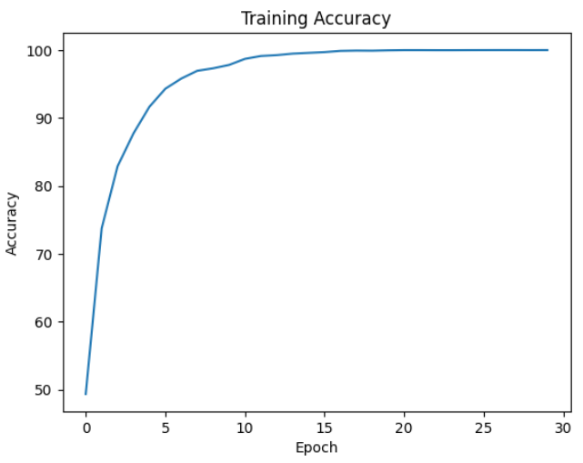

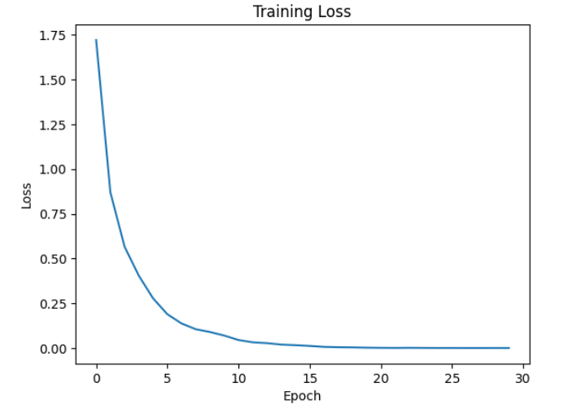 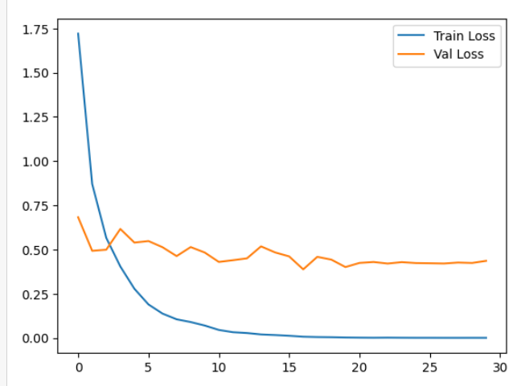

증폭 3 - Batch size 32 / 32 , Learning rate 0.001

#0 Loss: 2.0491 Acc: 41.8626% Time: 103.0496s

[Test Phase] Loss: 0.6670 Acc: 78.3333% Top3 Acc: 96.0000% Time: 105.0151s

#1 Loss: 1.0796 Acc: 67.8613% Time: 194.6044s

[Test Phase] Loss: 0.4542 Acc: 84.3333% Top3 Acc: 96.3333% Time: 196.8373s

#2 Loss: 0.7251 Acc: 78.5785% Time: 288.1627s

[Test Phase] Loss: 0.3953 Acc: 87.0000% Top3 Acc: 97.6667% Time: 290.4488s

#3 Loss: 0.5066 Acc: 85.2408% Time: 380.5081s

[Test Phase] Loss: 0.3694 Acc: 88.6667% Top3 Acc: 98.6667% Time: 382.7759s

#4 Loss: 0.3544 Acc: 90.1006% Time: 474.5826s

[Test Phase] Loss: 0.3123 Acc: 91.0000% Top3 Acc: 99.3333% Time: 476.4070s

#5 Loss: 0.2374 Acc: 93.4618% Time: 567.9821s

[Test Phase] Loss: 0.3742 Acc: 88.6667% Top3 Acc: 98.0000% Time: 570.1386s

#6 Loss: 0.1694 Acc: 95.5042% Time: 663.1961s

[Test Phase] Loss: 0.4934 Acc: 86.6667% Top3 Acc: 98.0000% Time: 665.4353s

#7 Loss: 0.1243 Acc: 96.7031% Time: 758.9583s

[Test Phase] Loss: 0.4154 Acc: 89.6667% Top3 Acc: 97.6667% Time: 761.0984s

#8 Loss: 0.0770 Acc: 98.1631% Time: 854.6577s

[Test Phase] Loss: 0.3728 Acc: 90.0000% Top3 Acc: 98.6667% Time: 857.1081s

#9 Loss: 0.0554 Acc: 98.6298% Time: 950.7793s

[Test Phase] Loss: 0.3846 Acc: 88.0000% Top3 Acc: 98.6667% Time: 953.3429s

#10 Loss: 0.0429 Acc: 99.0238% Time: 1046.6667s

[Test Phase] Loss: 0.4228 Acc: 89.6667% Top3 Acc: 98.0000% Time: 1049.2719s

#11 Loss: 0.0379 Acc: 99.1565% Time: 1152.2974s

[Test Phase] Loss: 0.3906 Acc: 88.6667% Top3 Acc: 98.6667% Time: 1154.5765s

#12 Loss: 0.0279 Acc: 99.4262% Time: 1246.3700s

[Test Phase] Loss: 0.4328 Acc: 89.6667% Top3 Acc: 98.6667% Time: 1248.2875s

#13 Loss: 0.0220 Acc: 99.5675% Time: 1339.6809s

[Test Phase] Loss: 0.3970 Acc: 89.6667% Top3 Acc: 98.3333% Time: 1342.0315s

#14 Loss: 0.0160 Acc: 99.7559% Time: 1438.8990s

[Test Phase] Loss: 0.4620 Acc: 88.3333% Top3 Acc: 98.0000% Time: 1441.2031s

#15 Loss: 0.0150 Acc: 99.7217% Time: 1532.8824s

[Test Phase] Loss: 0.4057 Acc: 88.0000% Top3 Acc: 98.0000% Time: 1535.3228s

#16 Loss: 0.0104 Acc: 99.8673% Time: 1627.1078s

[Test Phase] Loss: 0.4164 Acc: 89.0000% Top3 Acc: 98.3333% Time: 1629.5684s

#17 Loss: 0.0073 Acc: 99.9058% Time: 1721.7548s

[Test Phase] Loss: 0.4107 Acc: 89.3333% Top3 Acc: 98.0000% Time: 1724.1613s

#18 Loss: 0.0064 Acc: 99.9401% Time: 1819.1325s

[Test Phase] Loss: 0.4080 Acc: 89.6667% Top3 Acc: 98.3333% Time: 1821.1500s

#19 Loss: 0.0055 Acc: 99.9315% Time: 1912.9536s

[Test Phase] Loss: 0.4410 Acc: 88.3333% Top3 Acc: 98.0000% Time: 1915.3576s

#20 Loss: 0.0061 Acc: 99.8930% Time: 2004.5953s

[Test Phase] Loss: 0.4337 Acc: 90.0000% Top3 Acc: 98.6667% Time: 2006.9964s

#21 Loss: 0.0045 Acc: 99.9401% Time: 2096.9652s

[Test Phase] Loss: 0.4630 Acc: 89.0000% Top3 Acc: 98.0000% Time: 2098.9967s

#22 Loss: 0.0044 Acc: 99.9443% Time: 2188.9190s

[Test Phase] Loss: 0.4517 Acc: 89.3333% Top3 Acc: 98.3333% Time: 2190.9348s

#23 Loss: 0.0038 Acc: 99.9443% Time: 2278.7674s

[Test Phase] Loss: 0.4340 Acc: 89.0000% Top3 Acc: 98.6667% Time: 2280.8534s

#24 Loss: 0.0033 Acc: 99.9615% Time: 2369.6404s

[Test Phase] Loss: 0.4399 Acc: 89.0000% Top3 Acc: 98.3333% Time: 2371.9871s

#25 Loss: 0.0028 Acc: 99.9657% Time: 2461.4546s

[Test Phase] Loss: 0.4386 Acc: 89.6667% Top3 Acc: 99.0000% Time: 2463.3685s

#26 Loss: 0.0023 Acc: 99.9914% Time: 2550.5339s

[Test Phase] Loss: 0.4326 Acc: 90.0000% Top3 Acc: 99.0000% Time: 2552.3070s

#27 Loss: 0.0023 Acc: 99.9743% Time: 2639.7629s

[Test Phase] Loss: 0.4457 Acc: 90.6667% Top3 Acc: 99.0000% Time: 2641.6514s

#28 Loss: 0.0024 Acc: 99.9743% Time: 2729.5417s

[Test Phase] Loss: 0.4736 Acc: 89.0000% Top3 Acc: 98.6667% Time: 2731.5700s

#29 Loss: 0.0021 Acc: 99.9657% Time: 2819.4961s

[Test Phase] Loss: 0.4620 Acc: 88.0000% Top3 Acc: 98.6667% Time: 2821.4190s

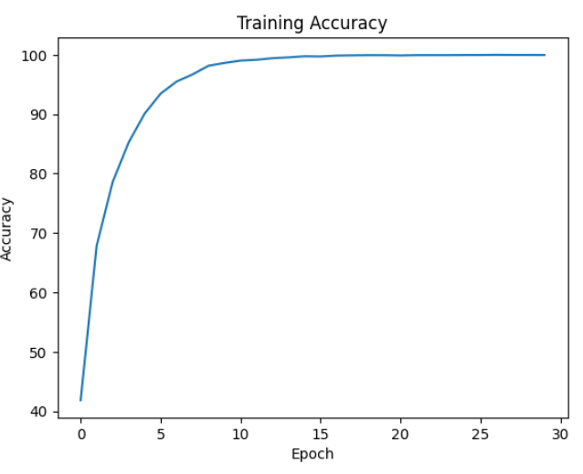 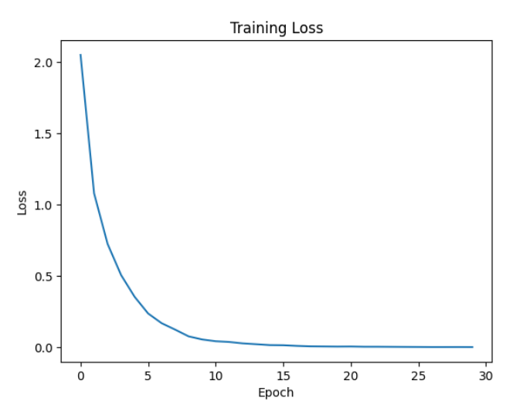 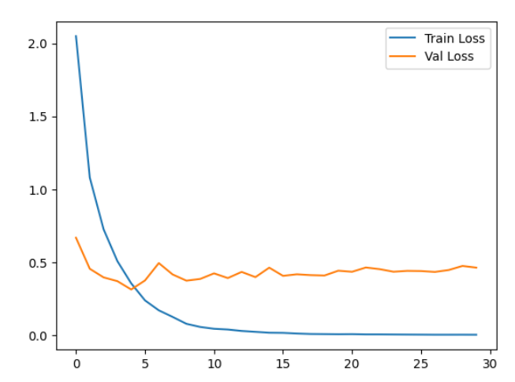

증폭 4 - Batch size 128 / 128 , Learning rate 0.01

#0 Loss: 1.6344 Acc: 51.4033% Time: 105.9603s

[Test Phase] Loss: 0.6019 Acc: 81.0000% Top3 Acc: 95.6667% Time: 108.3240s

#1 Loss: 0.8313 Acc: 74.4926% Time: 213.6170s

[Test Phase] Loss: 0.4833 Acc: 83.0000% Top3 Acc: 98.6667% Time: 216.1513s

#2 Loss: 0.5636 Acc: 82.5690% Time: 320.7465s

[Test Phase] Loss: 0.3996 Acc: 87.6667% Top3 Acc: 98.6667% Time: 323.2617s

#3 Loss: 0.3796 Acc: 88.4457% Time: 428.3731s

[Test Phase] Loss: 0.4337 Acc: 87.0000% Top3 Acc: 98.0000% Time: 431.0441s

#4 Loss: 0.2819 Acc: 91.1946% Time: 535.6462s

[Test Phase] Loss: 0.5253 Acc: 86.0000% Top3 Acc: 97.6667% Time: 538.5919s

#5 Loss: 0.2083 Acc: 93.6159% Time: 642.6986s

[Test Phase] Loss: 0.6388 Acc: 84.3333% Top3 Acc: 97.0000% Time: 645.2257s

#6 Loss: 0.1604 Acc: 95.0899% Time: 749.9551s

[Test Phase] Loss: 0.4978 Acc: 87.3333% Top3 Acc: 98.0000% Time: 752.4553s

#7 Loss: 0.1130 Acc: 96.5832% Time: 856.8442s

[Test Phase] Loss: 0.5330 Acc: 87.3333% Top3 Acc: 97.6667% Time: 859.2642s

#8 Loss: 0.0941 Acc: 97.0328% Time: 965.6811s

[Test Phase] Loss: 0.5279 Acc: 86.0000% Top3 Acc: 96.0000% Time: 968.4206s

#9 Loss: 0.0764 Acc: 97.6044% Time: 1073.5728s

[Test Phase] Loss: 0.5836 Acc: 85.3333% Top3 Acc: 98.0000% Time: 1076.6134s

#10 Loss: 0.0631 Acc: 98.0186% Time: 1181.5448s

[Test Phase] Loss: 0.5649 Acc: 88.3333% Top3 Acc: 98.3333% Time: 1184.2725s

#11 Loss: 0.0513 Acc: 98.3976% Time: 1288.8545s

[Test Phase] Loss: 0.5839 Acc: 84.0000% Top3 Acc: 98.0000% Time: 1291.9859s

#12 Loss: 0.0419 Acc: 98.7219% Time: 1396.2981s

[Test Phase] Loss: 0.5252 Acc: 89.0000% Top3 Acc: 97.3333% Time: 1399.1207s

#13 Loss: 0.0238 Acc: 99.3064% Time: 1504.3128s

[Test Phase] Loss: 0.5155 Acc: 87.6667% Top3 Acc: 97.0000% Time: 1507.0942s

#14 Loss: 0.0229 Acc: 99.3385% Time: 1610.9483s

[Test Phase] Loss: 0.6094 Acc: 86.3333% Top3 Acc: 97.6667% Time: 1613.7025s

#15 Loss: 0.0161 Acc: 99.5793% Time: 1719.2921s

[Test Phase] Loss: 0.5301 Acc: 86.6667% Top3 Acc: 97.6667% Time: 1722.5671s

#16 Loss: 0.0102 Acc: 99.7431% Time: 1827.2159s

[Test Phase] Loss: 0.4559 Acc: 90.3333% Top3 Acc: 98.6667% Time: 1829.9260s

#17 Loss: 0.0079 Acc: 99.7945% Time: 1933.6111s

[Test Phase] Loss: 0.4710 Acc: 88.3333% Top3 Acc: 97.6667% Time: 1936.2367s

#18 Loss: 0.0057 Acc: 99.8523% Time: 2041.8227s

[Test Phase] Loss: 0.4906 Acc: 87.3333% Top3 Acc: 98.0000% Time: 2044.6465s

#19 Loss: 0.0063 Acc: 99.8202% Time: 2148.7833s

[Test Phase] Loss: 0.4802 Acc: 88.6667% Top3 Acc: 98.3333% Time: 2151.4167s

#20 Loss: 0.0040 Acc: 99.9069% Time: 2255.4637s

[Test Phase] Loss: 0.4759 Acc: 89.3333% Top3 Acc: 98.6667% Time: 2258.2675s

#21 Loss: 0.0020 Acc: 99.9615% Time: 2362.0622s

[Test Phase] Loss: 0.5407 Acc: 89.0000% Top3 Acc: 99.0000% Time: 2365.2263s

#22 Loss: 0.0017 Acc: 99.9583% Time: 2469.9248s

[Test Phase] Loss: 0.5348 Acc: 88.3333% Top3 Acc: 99.0000% Time: 2472.5347s

#23 Loss: 0.0013 Acc: 99.9807% Time: 2576.5620s

[Test Phase] Loss: 0.5597 Acc: 88.0000% Top3 Acc: 98.6667% Time: 2579.0476s

#24 Loss: 0.0011 Acc: 99.9775% Time: 2682.6129s

[Test Phase] Loss: 0.5371 Acc: 88.6667% Top3 Acc: 98.3333% Time: 2685.1855s

#25 Loss: 0.0009 Acc: 99.9679% Time: 2789.1317s

[Test Phase] Loss: 0.5116 Acc: 89.0000% Top3 Acc: 98.6667% Time: 2791.8602s

#26 Loss: 0.0009 Acc: 99.9807% Time: 2896.2450s

[Test Phase] Loss: 0.5395 Acc: 88.3333% Top3 Acc: 98.0000% Time: 2898.7636s

#27 Loss: 0.0008 Acc: 99.9775% Time: 3002.2222s

[Test Phase] Loss: 0.5434 Acc: 88.0000% Top3 Acc: 98.3333% Time: 3005.0966s

#28 Loss: 0.0008 Acc: 99.9775% Time: 3109.2687s

[Test Phase] Loss: 0.5323 Acc: 88.0000% Top3 Acc: 98.3333% Time: 3111.8098s

#29 Loss: 0.0006 Acc: 99.9807% Time: 3216.0437s

[Test Phase] Loss: 0.5476 Acc: 87.6667% Top3 Acc: 98.6667% Time: 3218.6703s

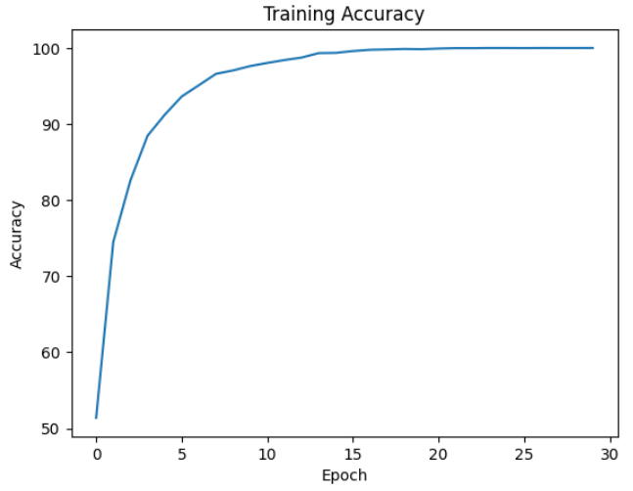 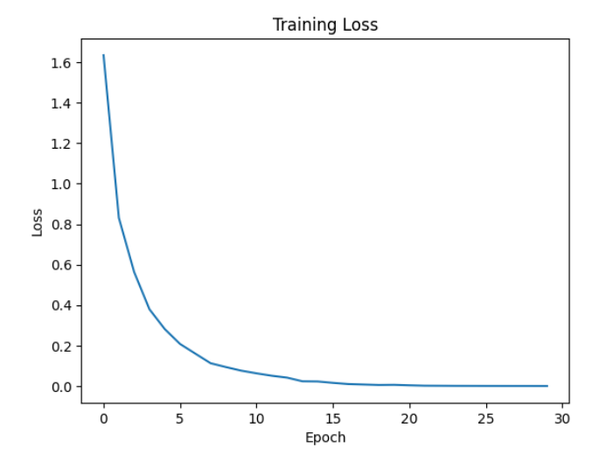 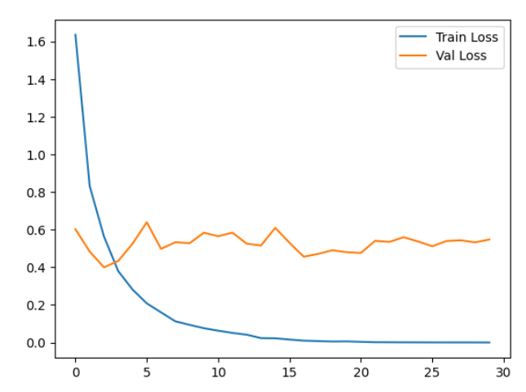

증폭 4 - Batch size 32 / 32 , Learning rate 0.001

#0 Loss: 1.9300 Acc: 44.9518% Time: 118.3040s

[Test Phase] Loss: 0.5945 Acc: 80.3333% Top3 Acc: 96.3333% Time: 120.5874s

#1 Loss: 1.0031 Acc: 69.9197% Time: 236.6341s

[Test Phase] Loss: 0.4429 Acc: 85.0000% Top3 Acc: 97.0000% Time: 238.6232s

#2 Loss: 0.6759 Acc: 79.7848% Time: 354.4172s

[Test Phase] Loss: 0.3494 Acc: 88.0000% Top3 Acc: 98.0000% Time: 356.5752s

#3 Loss: 0.4619 Acc: 86.4708% Time: 473.2347s

[Test Phase] Loss: 0.3711 Acc: 87.3333% Top3 Acc: 98.6667% Time: 475.5002s

#4 Loss: 0.3285 Acc: 90.5620% Time: 589.0471s

[Test Phase] Loss: 0.3682 Acc: 88.6667% Top3 Acc: 98.3333% Time: 590.6306s

#5 Loss: 0.2285 Acc: 93.4457% Time: 706.4040s

[Test Phase] Loss: 0.4143 Acc: 88.6667% Top3 Acc: 98.3333% Time: 708.3610s

#6 Loss: 0.1597 Acc: 95.6134% Time: 824.5992s

[Test Phase] Loss: 0.3733 Acc: 90.3333% Top3 Acc: 99.3333% Time: 826.4307s

#7 Loss: 0.1207 Acc: 96.7373% Time: 943.6052s

[Test Phase] Loss: 0.4134 Acc: 88.0000% Top3 Acc: 97.6667% Time: 945.6765s

#8 Loss: 0.0835 Acc: 97.7874% Time: 1063.7534s

[Test Phase] Loss: 0.4172 Acc: 88.6667% Top3 Acc: 97.3333% Time: 1065.9886s

#9 Loss: 0.0732 Acc: 98.0700% Time: 1181.4049s

[Test Phase] Loss: 0.4216 Acc: 89.0000% Top3 Acc: 99.0000% Time: 1183.2913s

#10 Loss: 0.0503 Acc: 98.7187% Time: 1299.6716s

[Test Phase] Loss: 0.4822 Acc: 88.6667% Top3 Acc: 98.6667% Time: 1301.5510s

#11 Loss: 0.0415 Acc: 98.9274% Time: 1418.0382s

[Test Phase] Loss: 0.4540 Acc: 89.6667% Top3 Acc: 97.6667% Time: 1419.9643s

#12 Loss: 0.0347 Acc: 99.1169% Time: 1534.9263s

[Test Phase] Loss: 0.4673 Acc: 88.3333% Top3 Acc: 97.6667% Time: 1536.8442s

#13 Loss: 0.0256 Acc: 99.3834% Time: 1651.9830s

[Test Phase] Loss: 0.4449 Acc: 89.0000% Top3 Acc: 97.6667% Time: 1653.9001s

#14 Loss: 0.0289 Acc: 99.2742% Time: 1769.9464s

[Test Phase] Loss: 0.4579 Acc: 87.6667% Top3 Acc: 98.3333% Time: 1771.9845s

#15 Loss: 0.0195 Acc: 99.5568% Time: 1885.1902s

[Test Phase] Loss: 0.4918 Acc: 87.0000% Top3 Acc: 98.0000% Time: 1887.0375s

#16 Loss: 0.0204 Acc: 99.5151% Time: 2002.0652s

[Test Phase] Loss: 0.4113 Acc: 89.6667% Top3 Acc: 98.6667% Time: 2004.0087s

#17 Loss: 0.0168 Acc: 99.6436% Time: 2119.0994s

[Test Phase] Loss: 0.4439 Acc: 89.3333% Top3 Acc: 98.0000% Time: 2120.9638s

#18 Loss: 0.0137 Acc: 99.6885% Time: 2235.4341s

[Test Phase] Loss: 0.4396 Acc: 89.3333% Top3 Acc: 97.6667% Time: 2237.2577s

#19 Loss: 0.0131 Acc: 99.7046% Time: 2352.1646s

[Test Phase] Loss: 0.4596 Acc: 88.3333% Top3 Acc: 98.6667% Time: 2354.0306s

#20 Loss: 0.0106 Acc: 99.8009% Time: 2469.7967s

[Test Phase] Loss: 0.4693 Acc: 89.3333% Top3 Acc: 98.3333% Time: 2471.6111s

#21 Loss: 0.0098 Acc: 99.8105% Time: 2586.3299s

[Test Phase] Loss: 0.4320 Acc: 89.6667% Top3 Acc: 98.3333% Time: 2588.1191s

#22 Loss: 0.0080 Acc: 99.8459% Time: 2704.3173s

[Test Phase] Loss: 0.4600 Acc: 89.3333% Top3 Acc: 97.3333% Time: 2706.1670s

#23 Loss: 0.0063 Acc: 99.8812% Time: 2823.1983s

[Test Phase] Loss: 0.4531 Acc: 90.0000% Top3 Acc: 98.0000% Time: 2825.0220s

#24 Loss: 0.0089 Acc: 99.7913% Time: 2939.8481s

[Test Phase] Loss: 0.4652 Acc: 90.0000% Top3 Acc: 98.0000% Time: 2941.7097s

#25 Loss: 0.0050 Acc: 99.9037% Time: 3058.1582s

[Test Phase] Loss: 0.4331 Acc: 90.3333% Top3 Acc: 97.6667% Time: 3060.1474s

#26 Loss: 0.0043 Acc: 99.9454% Time: 3176.4925s

[Test Phase] Loss: 0.4414 Acc: 90.0000% Top3 Acc: 98.3333% Time: 3178.4027s

#27 Loss: 0.0059 Acc: 99.8908% Time: 3293.3764s

[Test Phase] Loss: 0.4836 Acc: 90.0000% Top3 Acc: 97.0000% Time: 3295.1658s

#28 Loss: 0.0039 Acc: 99.9454% Time: 3408.9362s

[Test Phase] Loss: 0.5218 Acc: 88.6667% Top3 Acc: 97.3333% Time: 3411.1177s

#29 Loss: 0.0041 Acc: 99.9486% Time: 3527.9686s

[Test Phase] Loss: 0.5121 Acc: 89.0000% Top3 Acc: 97.0000% Time: 3529.8964s

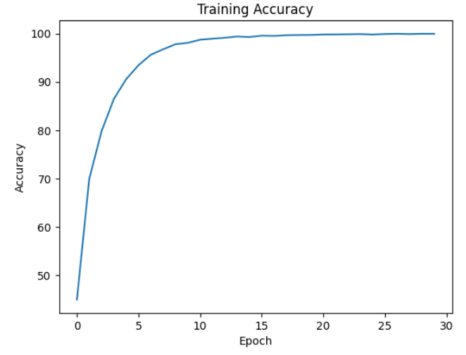 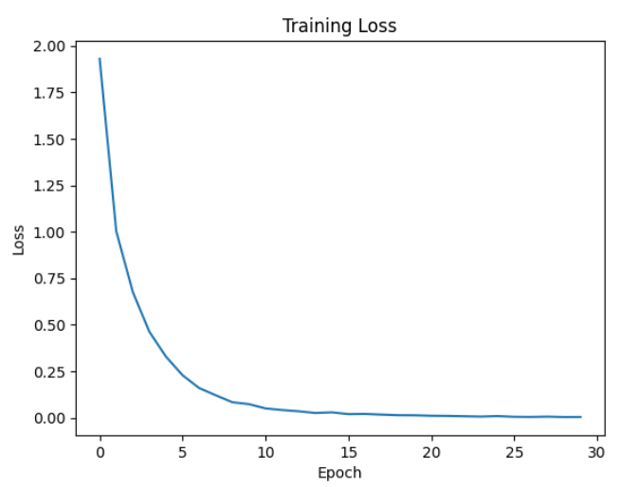 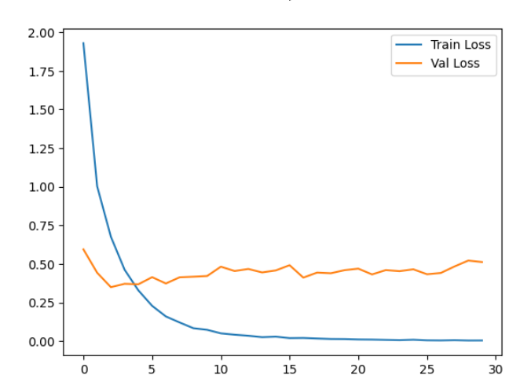

증폭 5 - Batch size 128 / 128 , Learning rate 0.01

#0 Loss: 1.5529 Acc: 53.7392% Time: 131.3495s

[Test Phase] Loss: 0.6068 Acc: 80.3333% Top3 Acc: 96.6667% Time: 134.1512s

#1 Loss: 0.8347 Acc: 74.6384% Time: 262.5279s

[Test Phase] Loss: 0.5669 Acc: 80.0000% Top3 Acc: 96.6667% Time: 265.1837s

#2 Loss: 0.5468 Acc: 83.1959% Time: 392.9042s

[Test Phase] Loss: 0.5286 Acc: 88.3333% Top3 Acc: 97.3333% Time: 395.8207s

#3 Loss: 0.4002 Acc: 87.6994% Time: 523.0933s

[Test Phase] Loss: 0.5490 Acc: 86.0000% Top3 Acc: 97.3333% Time: 525.6883s

#4 Loss: 0.2988 Acc: 90.8259% Time: 652.2692s

[Test Phase] Loss: 0.6484 Acc: 84.0000% Top3 Acc: 97.6667% Time: 654.8309s

#5 Loss: 0.2435 Acc: 92.5241% Time: 782.4644s

[Test Phase] Loss: 0.5153 Acc: 86.3333% Top3 Acc: 97.6667% Time: 785.0507s

#6 Loss: 0.1971 Acc: 94.0321% Time: 913.7485s

[Test Phase] Loss: 0.6386 Acc: 84.6667% Top3 Acc: 98.0000% Time: 916.6201s

#7 Loss: 0.1242 Acc: 96.0976% Time: 1044.8913s

[Test Phase] Loss: 0.5219 Acc: 84.6667% Top3 Acc: 97.6667% Time: 1047.9130s

#8 Loss: 0.1311 Acc: 95.9332% Time: 1175.5585s

[Test Phase] Loss: 0.5476 Acc: 87.6667% Top3 Acc: 96.6667% Time: 1178.5298s

#9 Loss: 0.1039 Acc: 96.7425% Time: 1305.8729s

[Test Phase] Loss: 0.5562 Acc: 86.6667% Top3 Acc: 96.6667% Time: 1308.6799s

#10 Loss: 0.0699 Acc: 97.9525% Time: 1437.2936s

[Test Phase] Loss: 0.5785 Acc: 87.0000% Top3 Acc: 97.0000% Time: 1440.2150s

#11 Loss: 0.0789 Acc: 97.5902% Time: 1567.6289s

[Test Phase] Loss: 0.5692 Acc: 86.6667% Top3 Acc: 97.0000% Time: 1570.2858s

#12 Loss: 0.0630 Acc: 98.0732% Time: 1699.0257s

[Test Phase] Loss: 0.6692 Acc: 88.0000% Top3 Acc: 96.0000% Time: 1701.8196s

#13 Loss: 0.0653 Acc: 97.9165% Time: 1829.8055s

[Test Phase] Loss: 0.7290 Acc: 86.3333% Top3 Acc: 97.0000% Time: 1832.5091s

#14 Loss: 0.0399 Acc: 98.8131% Time: 1961.4120s

[Test Phase] Loss: 0.6649 Acc: 87.6667% Top3 Acc: 96.3333% Time: 1964.6054s

#15 Loss: 0.0386 Acc: 98.8362% Time: 2091.4185s

[Test Phase] Loss: 0.8024 Acc: 85.3333% Top3 Acc: 97.0000% Time: 2094.0898s

#16 Loss: 0.0378 Acc: 98.8876% Time: 2220.9209s

[Test Phase] Loss: 0.8074 Acc: 86.0000% Top3 Acc: 96.0000% Time: 2223.9010s

#17 Loss: 0.0342 Acc: 99.0674% Time: 2349.4912s

[Test Phase] Loss: 0.7475 Acc: 85.6667% Top3 Acc: 97.0000% Time: 2352.0800s

#18 Loss: 0.0352 Acc: 98.9698% Time: 2479.0578s

[Test Phase] Loss: 0.6111 Acc: 88.0000% Top3 Acc: 98.0000% Time: 2481.4607s

#19 Loss: 0.0364 Acc: 98.8927% Time: 2607.2507s

[Test Phase] Loss: 0.5768 Acc: 89.0000% Top3 Acc: 97.0000% Time: 2609.7443s

#20 Loss: 0.0489 Acc: 98.4945% Time: 2735.4373s

[Test Phase] Loss: 0.5955 Acc: 87.6667% Top3 Acc: 97.3333% Time: 2738.5402s

#21 Loss: 0.0144 Acc: 99.6198% Time: 2864.6037s

[Test Phase] Loss: 0.7024 Acc: 87.6667% Top3 Acc: 97.3333% Time: 2867.3217s

#22 Loss: 0.0545 Acc: 98.3558% Time: 2993.5362s

[Test Phase] Loss: 0.5453 Acc: 87.0000% Top3 Acc: 97.3333% Time: 2996.0197s

#23 Loss: 0.0173 Acc: 99.5119% Time: 3122.0151s

[Test Phase] Loss: 0.6569 Acc: 87.3333% Top3 Acc: 96.3333% Time: 3124.5360s

#24 Loss: 0.0084 Acc: 99.7585% Time: 3252.6670s

[Test Phase] Loss: 0.6777 Acc: 87.3333% Top3 Acc: 97.3333% Time: 3255.1316s

#25 Loss: 0.0065 Acc: 99.8202% Time: 3382.0423s

[Test Phase] Loss: 0.6058 Acc: 88.6667% Top3 Acc: 98.0000% Time: 3385.2738s

#26 Loss: 0.0060 Acc: 99.8330% Time: 3512.6356s

[Test Phase] Loss: 0.5662 Acc: 87.0000% Top3 Acc: 97.6667% Time: 3515.1588s

#27 Loss: 0.0042 Acc: 99.8844% Time: 3641.9882s

[Test Phase] Loss: 0.6195 Acc: 88.6667% Top3 Acc: 97.6667% Time: 3644.7687s

#28 Loss: 0.0021 Acc: 99.9563% Time: 3770.5765s

[Test Phase] Loss: 0.5741 Acc: 89.6667% Top3 Acc: 98.3333% Time: 3773.0672s

#29 Loss: 0.0010 Acc: 99.9794% Time: 3897.9781s

[Test Phase] Loss: 0.5938 Acc: 89.0000% Top3 Acc: 97.3333% Time: 3900.4515s

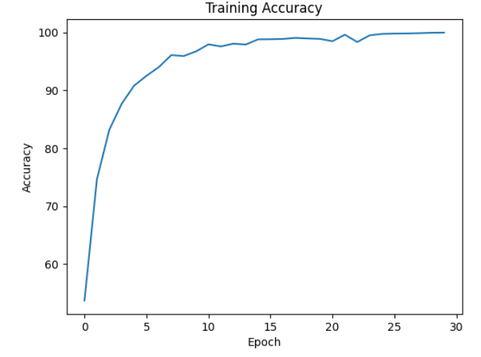 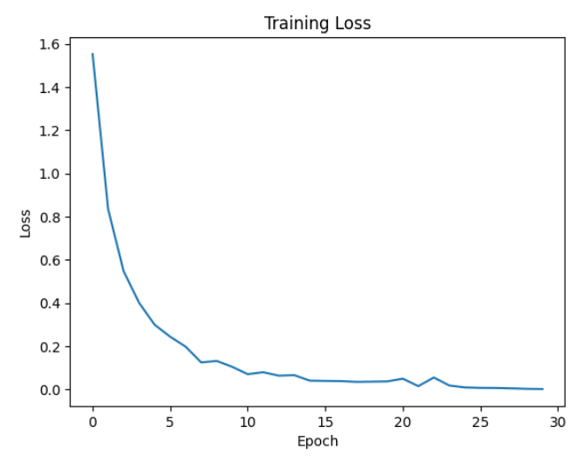 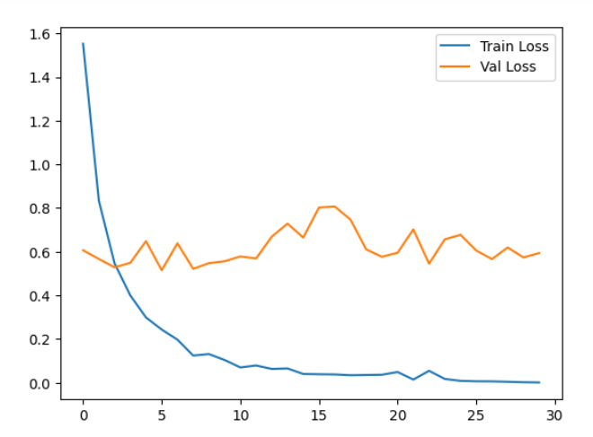

증폭 5 - Batch size 32 / 32 , Learning rate 0.001

#0 Loss: 1.8178 Acc: 47.4271% Time: 147.2621s

[Test Phase] Loss: 0.5557 Acc: 79.6667% Top3 Acc: 97.0000% Time: 149.2564s

#1 Loss: 0.9304 Acc: 72.1747% Time: 293.5743s

[Test Phase] Loss: 0.3856 Acc: 86.0000% Top3 Acc: 97.6667% Time: 295.5431s

#2 Loss: 0.6243 Acc: 81.4592% Time: 440.2414s

[Test Phase] Loss: 0.4224 Acc: 87.3333% Top3 Acc: 96.6667% Time: 442.3567s

#3 Loss: 0.4361 Acc: 87.1111% Time: 585.1929s

[Test Phase] Loss: 0.4123 Acc: 88.3333% Top3 Acc: 96.6667% Time: 586.9219s

#4 Loss: 0.3105 Acc: 90.9852% Time: 731.4805s

[Test Phase] Loss: 0.4169 Acc: 87.6667% Top3 Acc: 98.3333% Time: 733.5254s

#5 Loss: 0.2166 Acc: 93.7624% Time: 878.9052s

[Test Phase] Loss: 0.4282 Acc: 87.3333% Top3 Acc: 98.3333% Time: 880.9798s

#6 Loss: 0.1555 Acc: 95.6249% Time: 1027.3230s

[Test Phase] Loss: 0.4839 Acc: 87.0000% Top3 Acc: 97.6667% Time: 1029.1844s

#7 Loss: 0.1093 Acc: 97.0482% Time: 1175.2960s

[Test Phase] Loss: 0.4573 Acc: 87.6667% Top3 Acc: 98.6667% Time: 1177.3931s

#8 Loss: 0.0847 Acc: 97.6596% Time: 1322.3439s

[Test Phase] Loss: 0.3981 Acc: 88.0000% Top3 Acc: 99.3333% Time: 1324.2732s

#9 Loss: 0.0704 Acc: 98.0424% Time: 1469.4446s

[Test Phase] Loss: 0.4157 Acc: 88.0000% Top3 Acc: 98.6667% Time: 1471.0969s

#10 Loss: 0.0503 Acc: 98.7283% Time: 1616.4923s

[Test Phase] Loss: 0.4233 Acc: 88.3333% Top3 Acc: 98.3333% Time: 1618.5721s

#11 Loss: 0.0387 Acc: 99.0700% Time: 1763.1790s

[Test Phase] Loss: 0.4454 Acc: 88.6667% Top3 Acc: 97.6667% Time: 1765.3045s

#12 Loss: 0.0363 Acc: 99.0597% Time: 1910.3200s

[Test Phase] Loss: 0.4808 Acc: 88.6667% Top3 Acc: 99.0000% Time: 1912.3731s

#13 Loss: 0.0295 Acc: 99.2781% Time: 2056.5908s

[Test Phase] Loss: 0.5267 Acc: 88.0000% Top3 Acc: 98.0000% Time: 2058.5542s

#14 Loss: 0.0227 Acc: 99.4451% Time: 2202.5925s

[Test Phase] Loss: 0.5126 Acc: 87.6667% Top3 Acc: 98.3333% Time: 2204.4278s

#15 Loss: 0.0161 Acc: 99.6326% Time: 2348.3621s

[Test Phase] Loss: 0.5441 Acc: 88.6667% Top3 Acc: 98.6667% Time: 2350.3676s

#16 Loss: 0.0126 Acc: 99.7611% Time: 2493.3271s

[Test Phase] Loss: 0.5254 Acc: 88.3333% Top3 Acc: 98.6667% Time: 2495.0262s

#17 Loss: 0.0124 Acc: 99.7457% Time: 2638.8987s

[Test Phase] Loss: 0.5292 Acc: 87.6667% Top3 Acc: 98.6667% Time: 2640.6598s

#18 Loss: 0.0115 Acc: 99.7482% Time: 2785.0850s

[Test Phase] Loss: 0.5051 Acc: 87.3333% Top3 Acc: 98.3333% Time: 2787.5749s

#19 Loss: 0.0108 Acc: 99.7713% Time: 2932.2991s

[Test Phase] Loss: 0.4933 Acc: 89.6667% Top3 Acc: 98.6667% Time: 2934.1108s

#20 Loss: 0.0111 Acc: 99.7585% Time: 3078.0902s

[Test Phase] Loss: 0.5295 Acc: 88.0000% Top3 Acc: 98.3333% Time: 3080.0026s

#21 Loss: 0.0080 Acc: 99.8561% Time: 3224.5949s

[Test Phase] Loss: 0.5178 Acc: 88.3333% Top3 Acc: 98.6667% Time: 3226.2969s

#22 Loss: 0.0084 Acc: 99.8176% Time: 3370.4356s

[Test Phase] Loss: 0.5605 Acc: 88.0000% Top3 Acc: 98.0000% Time: 3372.4918s

#23 Loss: 0.0066 Acc: 99.8792% Time: 3517.1820s

[Test Phase] Loss: 0.5648 Acc: 88.6667% Top3 Acc: 98.6667% Time: 3518.9071s

#24 Loss: 0.0055 Acc: 99.8741% Time: 3663.8255s

[Test Phase] Loss: 0.5537 Acc: 89.0000% Top3 Acc: 98.6667% Time: 3665.6517s

#25 Loss: 0.0054 Acc: 99.8844% Time: 3805.0490s

[Test Phase] Loss: 0.5424 Acc: 89.3333% Top3 Acc: 99.3333% Time: 3806.6247s

#26 Loss: 0.0050 Acc: 99.9024% Time: 3944.7961s

[Test Phase] Loss: 0.5449 Acc: 87.6667% Top3 Acc: 99.3333% Time: 3946.2599s

#27 Loss: 0.0035 Acc: 99.9589% Time: 4083.0031s

[Test Phase] Loss: 0.4972 Acc: 89.0000% Top3 Acc: 99.3333% Time: 4084.5184s

#28 Loss: 0.0030 Acc: 99.9538% Time: 4224.0769s

[Test Phase] Loss: 0.5331 Acc: 89.0000% Top3 Acc: 99.0000% Time: 4225.7990s

#29 Loss: 0.0034 Acc: 99.9332% Time: 4367.0377s

[Test Phase] Loss: 0.5890 Acc: 88.6667% Top3 Acc: 98.6667% Time: 4368.7825s

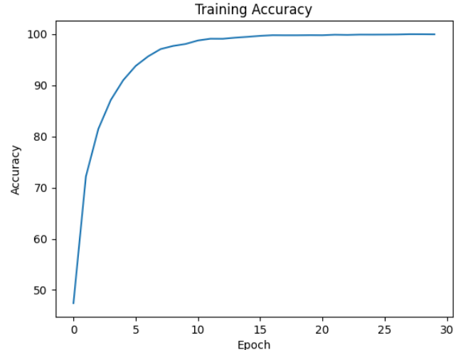

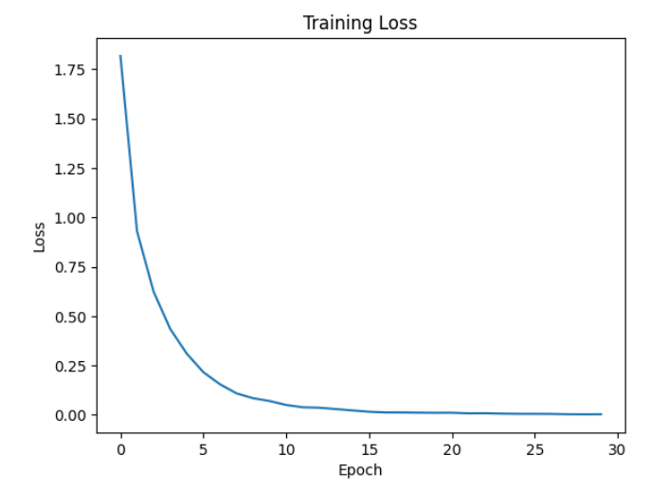 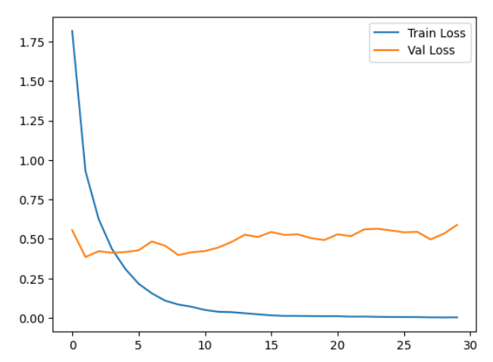

증폭 6 - Batch size 128 / 128 , Learning rate 0.01

#0 Loss: 1.4948 Acc: 55.3586% Time: 153.9305s

[Test Phase] Loss: 0.5154 Acc: 80.6667% Top3 Acc: 98.3333% Time: 156.5322s

#1 Loss: 0.7604 Acc: 76.7823% Time: 310.8565s

[Test Phase] Loss: 0.5950 Acc: 83.3333% Top3 Acc: 95.6667% Time: 313.9834s

#2 Loss: 0.5107 Acc: 84.3096% Time: 471.0226s

[Test Phase] Loss: 0.5331 Acc: 86.3333% Top3 Acc: 96.3333% Time: 474.4205s

#3 Loss: 0.3620 Acc: 88.7519% Time: 629.5028s

[Test Phase] Loss: 0.5946 Acc: 83.0000% Top3 Acc: 97.0000% Time: 632.0070s

#4 Loss: 0.2737 Acc: 91.5243% Time: 783.8250s

[Test Phase] Loss: 0.6119 Acc: 86.0000% Top3 Acc: 95.3333% Time: 786.2366s

#5 Loss: 0.1940 Acc: 94.0120% Time: 937.6330s

[Test Phase] Loss: 0.6532 Acc: 84.6667% Top3 Acc: 96.3333% Time: 940.0964s

#6 Loss: 0.1455 Acc: 95.4549% Time: 1090.9874s

[Test Phase] Loss: 0.6667 Acc: 87.3333% Top3 Acc: 96.3333% Time: 1093.3390s

#7 Loss: 0.1222 Acc: 96.2021% Time: 1244.6158s

[Test Phase] Loss: 0.5906 Acc: 88.6667% Top3 Acc: 96.6667% Time: 1246.9527s

#8 Loss: 0.1042 Acc: 96.8080% Time: 1397.5893s

[Test Phase] Loss: 0.6098 Acc: 87.3333% Top3 Acc: 97.0000% Time: 1399.9578s

#9 Loss: 0.0812 Acc: 97.4802% Time: 1551.0225s

[Test Phase] Loss: 0.7306 Acc: 87.0000% Top3 Acc: 96.3333% Time: 1553.3997s

#10 Loss: 0.0618 Acc: 98.0668% Time: 1705.8402s

[Test Phase] Loss: 0.6098 Acc: 86.6667% Top3 Acc: 97.6667% Time: 1708.4654s

#11 Loss: 0.0532 Acc: 98.3986% Time: 1860.3779s

[Test Phase] Loss: 0.6439 Acc: 87.3333% Top3 Acc: 97.0000% Time: 1862.8564s

#12 Loss: 0.0406 Acc: 98.7262% Time: 2011.0792s

[Test Phase] Loss: 0.6683 Acc: 87.0000% Top3 Acc: 96.0000% Time: 2013.4333s

#13 Loss: 0.0310 Acc: 99.0666% Time: 2161.7121s

[Test Phase] Loss: 0.7181 Acc: 87.6667% Top3 Acc: 97.0000% Time: 2163.9838s

#14 Loss: 0.0281 Acc: 99.1651% Time: 2313.8931s

[Test Phase] Loss: 0.6215 Acc: 87.0000% Top3 Acc: 97.0000% Time: 2316.5539s

#15 Loss: 0.0255 Acc: 99.2486% Time: 2466.6245s

[Test Phase] Loss: 0.6616 Acc: 86.6667% Top3 Acc: 96.6667% Time: 2468.9847s

#16 Loss: 0.0169 Acc: 99.5055% Time: 2619.6325s

[Test Phase] Loss: 0.6742 Acc: 86.6667% Top3 Acc: 97.0000% Time: 2622.3663s

#17 Loss: 0.0135 Acc: 99.6425% Time: 2770.8235s

[Test Phase] Loss: 0.6733 Acc: 87.3333% Top3 Acc: 96.6667% Time: 2773.2992s

#18 Loss: 0.0143 Acc: 99.6082% Time: 2921.5708s

[Test Phase] Loss: 0.7114 Acc: 87.0000% Top3 Acc: 96.3333% Time: 2924.0327s

#19 Loss: 0.0112 Acc: 99.6832% Time: 3072.4562s

[Test Phase] Loss: 0.6515 Acc: 86.0000% Top3 Acc: 97.6667% Time: 3074.9808s

#20 Loss: 0.0066 Acc: 99.8245% Time: 3223.9269s

[Test Phase] Loss: 0.6297 Acc: 88.0000% Top3 Acc: 96.6667% Time: 3226.7147s

#21 Loss: 0.0047 Acc: 99.8566% Time: 3376.6543s

[Test Phase] Loss: 0.5990 Acc: 88.0000% Top3 Acc: 96.6667% Time: 3379.4885s

#22 Loss: 0.0032 Acc: 99.9272% Time: 3529.6772s

[Test Phase] Loss: 0.6309 Acc: 87.3333% Top3 Acc: 96.6667% Time: 3532.7388s

#23 Loss: 0.0040 Acc: 99.8930% Time: 3684.1607s

[Test Phase] Loss: 0.5576 Acc: 89.0000% Top3 Acc: 97.6667% Time: 3686.8185s

#24 Loss: 0.0023 Acc: 99.9508% Time: 3838.1848s

[Test Phase] Loss: 0.5876 Acc: 89.6667% Top3 Acc: 97.3333% Time: 3840.9717s

#25 Loss: 0.0020 Acc: 99.9508% Time: 3991.7888s

[Test Phase] Loss: 0.5830 Acc: 89.3333% Top3 Acc: 97.6667% Time: 3994.8385s

#26 Loss: 0.0012 Acc: 99.9700% Time: 4145.7195s

[Test Phase] Loss: 0.5959 Acc: 88.6667% Top3 Acc: 97.3333% Time: 4148.5762s

#27 Loss: 0.0012 Acc: 99.9636% Time: 4299.3913s

[Test Phase] Loss: 0.6051 Acc: 89.3333% Top3 Acc: 97.3333% Time: 4302.0899s

#28 Loss: 0.0007 Acc: 99.9872% Time: 4452.0688s

[Test Phase] Loss: 0.6130 Acc: 89.0000% Top3 Acc: 97.3333% Time: 4454.9822s

#29 Loss: 0.0006 Acc: 99.9850% Time: 4607.2546s

[Test Phase] Loss: 0.5983 Acc: 89.3333% Top3 Acc: 97.3333% Time: 4610.2746s

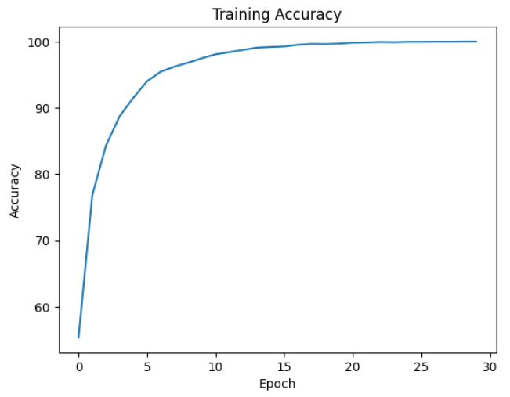 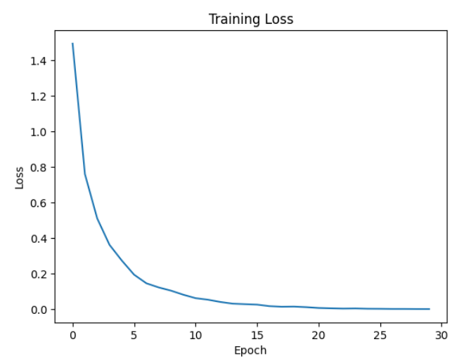 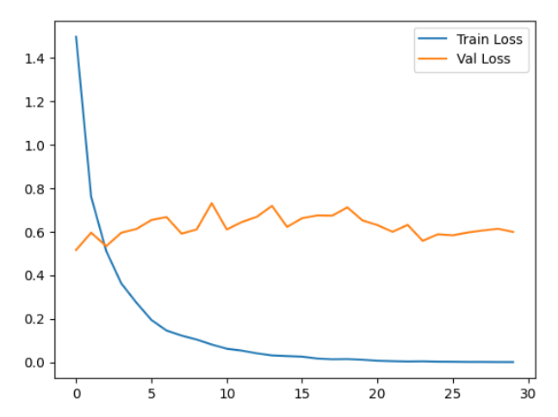

증폭 6 - Batch size 32 / 32 , Learning rate 0.001

#0 Loss: 1.7311 Acc: 49.5568% Time: 172.7529s

[Test Phase] Loss: 0.5067 Acc: 81.6667% Top3 Acc: 98.0000% Time: 174.8397s

#1 Loss: 0.8881 Acc: 73.4061% Time: 355.0397s

[Test Phase] Loss: 0.3636 Acc: 87.6667% Top3 Acc: 98.3333% Time: 357.7243s

#2 Loss: 0.5834 Acc: 82.5519% Time: 538.2911s

[Test Phase] Loss: 0.3529 Acc: 89.3333% Top3 Acc: 98.0000% Time: 539.8868s

#3 Loss: 0.4118 Acc: 87.7136% Time: 708.7020s

[Test Phase] Loss: 0.4749 Acc: 85.6667% Top3 Acc: 97.3333% Time: 710.5538s

#4 Loss: 0.2859 Acc: 91.6635% Time: 880.1142s

[Test Phase] Loss: 0.4286 Acc: 88.6667% Top3 Acc: 97.0000% Time: 881.9898s

#5 Loss: 0.2061 Acc: 94.0719% Time: 1051.4477s

[Test Phase] Loss: 0.4409 Acc: 88.6667% Top3 Acc: 98.0000% Time: 1053.0496s

#6 Loss: 0.1545 Acc: 95.5834% Time: 1221.1199s

[Test Phase] Loss: 0.3756 Acc: 90.0000% Top3 Acc: 98.6667% Time: 1222.9665s

#7 Loss: 0.1093 Acc: 97.0113% Time: 1391.4322s

[Test Phase] Loss: 0.4999 Acc: 87.0000% Top3 Acc: 97.3333% Time: 1393.3074s

#8 Loss: 0.0866 Acc: 97.5680% Time: 1561.9997s

[Test Phase] Loss: 0.4937 Acc: 87.6667% Top3 Acc: 97.6667% Time: 1563.6565s

#9 Loss: 0.0690 Acc: 98.0839% Time: 1733.2168s

[Test Phase] Loss: 0.4706 Acc: 87.0000% Top3 Acc: 97.0000% Time: 1734.8602s

#10 Loss: 0.0534 Acc: 98.6042% Time: 1900.8485s

[Test Phase] Loss: 0.4996 Acc: 88.3333% Top3 Acc: 97.6667% Time: 1902.3916s

#11 Loss: 0.0418 Acc: 98.9146% Time: 2066.3196s

[Test Phase] Loss: 0.4422 Acc: 88.3333% Top3 Acc: 97.3333% Time: 2067.9666s

#12 Loss: 0.0320 Acc: 99.1565% Time: 2235.1671s

[Test Phase] Loss: 0.4669 Acc: 88.6667% Top3 Acc: 98.0000% Time: 2237.1020s

#13 Loss: 0.0265 Acc: 99.3342% Time: 2408.0503s

[Test Phase] Loss: 0.4805 Acc: 88.6667% Top3 Acc: 97.3333% Time: 2410.3420s

#14 Loss: 0.0241 Acc: 99.3963% Time: 2580.8380s

[Test Phase] Loss: 0.4651 Acc: 87.0000% Top3 Acc: 98.0000% Time: 2582.9080s

#15 Loss: 0.0217 Acc: 99.4541% Time: 2753.3920s

[Test Phase] Loss: 0.5077 Acc: 87.3333% Top3 Acc: 97.3333% Time: 2755.1426s

#16 Loss: 0.0191 Acc: 99.5183% Time: 2927.2156s

[Test Phase] Loss: 0.5354 Acc: 88.3333% Top3 Acc: 97.6667% Time: 2928.9990s

#17 Loss: 0.0186 Acc: 99.5183% Time: 3099.8717s

[Test Phase] Loss: 0.5736 Acc: 87.0000% Top3 Acc: 97.6667% Time: 3101.5383s

#18 Loss: 0.0136 Acc: 99.6810% Time: 3271.5571s

[Test Phase] Loss: 0.5260 Acc: 87.6667% Top3 Acc: 98.3333% Time: 3273.2378s

#19 Loss: 0.0114 Acc: 99.7174% Time: 3443.8452s

[Test Phase] Loss: 0.5292 Acc: 87.0000% Top3 Acc: 98.3333% Time: 3445.7104s

#20 Loss: 0.0101 Acc: 99.7859% Time: 3617.0348s

[Test Phase] Loss: 0.5256 Acc: 89.0000% Top3 Acc: 98.6667% Time: 3618.9749s

#21 Loss: 0.0089 Acc: 99.8138% Time: 3791.8014s

[Test Phase] Loss: 0.5666 Acc: 87.3333% Top3 Acc: 98.3333% Time: 3793.8277s

#22 Loss: 0.0079 Acc: 99.8223% Time: 3965.7344s

[Test Phase] Loss: 0.5137 Acc: 87.0000% Top3 Acc: 98.6667% Time: 3967.7389s

#23 Loss: 0.0056 Acc: 99.8780% Time: 4139.5623s

[Test Phase] Loss: 0.4924 Acc: 87.0000% Top3 Acc: 98.3333% Time: 4141.6156s

#24 Loss: 0.0057 Acc: 99.8673% Time: 4314.2363s

[Test Phase] Loss: 0.5079 Acc: 87.3333% Top3 Acc: 98.0000% Time: 4316.0782s

#25 Loss: 0.0048 Acc: 99.9079% Time: 4490.0983s

[Test Phase] Loss: 0.5285 Acc: 89.0000% Top3 Acc: 97.6667% Time: 4491.9749s

#26 Loss: 0.0036 Acc: 99.9465% Time: 4664.5297s

[Test Phase] Loss: 0.5292 Acc: 89.0000% Top3 Acc: 98.3333% Time: 4666.4079s

#27 Loss: 0.0028 Acc: 99.9572% Time: 4837.1697s

[Test Phase] Loss: 0.5263 Acc: 88.3333% Top3 Acc: 98.6667% Time: 4839.0449s

#28 Loss: 0.0027 Acc: 99.9636% Time: 5007.9712s

[Test Phase] Loss: 0.5117 Acc: 89.3333% Top3 Acc: 98.3333% Time: 5009.8145s

#29 Loss: 0.0022 Acc: 99.9743% Time: 5177.5081s

[Test Phase] Loss: 0.5097 Acc: 90.6667% Top3 Acc: 97.0000% Time: 5179.5709s

